

LAB EXPERIMENT RECORD

SET 21

Department | Artificial Intelligence and Data Science
Course Code / Course Name | DSA0601 / Data Handling and Visualization
Name / Register Number | K.L DINESH ESHWAR / 192425027
Date / Day | 13/10/2026

Aim
To analyze energy consumption data analysis using the requested visualizations and dashboard views.

Dataset
Energy Consumption Data Analysis
Sector | Region | Month | Temperature_C | Units_Consumed | Cost_INR | Renewable_Usage | Peak_Hours
Residential | North | Jan | 15 | 320 | 2100 | 22 | 4
Commercial | South | Jan | 24 | 540 | 3600 | 18 | 6
Industrial | West | Feb | 20 | 880 | 5900 | 12 | 8
Residential | East | Feb | 18 | 350 | 2300 | 25 | 5
Commercial | North | Mar | 28 | 610 | 4100 | 20 | 7
Industrial | South | Mar | 30 | 920 | 6200 | 15 | 9

R Data Setup
Run this setup once before the R programs below. The dataset is defined inline so each record can be copied and run without a separate CSV file.
R data setup
dat <- data.frame(
Sector = c("Residential", "Commercial", "Industrial", "Residential", "Commercial", "Industrial"),
Region = c("North", "South", "West", "East", "North", "South"),
Month = c("Jan", "Jan", "Feb", "Feb", "Mar", "Mar"),
Temperature_C = c(15, 24, 20, 18, 28, 30),
Units_Consumed = c(320, 540, 880, 350, 610, 920),
Cost_INR = c(2100, 3600, 5900, 2300, 4100, 6200),
Renewable_Usage = c(22, 18, 12, 25, 20, 15),
Peak_Hours = c(4, 6, 8, 5, 7, 9)
)

PROGRAM 1: Histogram and Density of Energy Use
Plot a histogram with a density overlay for Units_Consumed and compare consumption patterns.
R code
hist(dat$Units_Consumed, probability=TRUE, col="lightblue", border="white", xlab="Units consumed (kWh)", main="Energy Consumption Distribution")
lines(density(dat$Units_Consumed), col="#E68A36", lwd=2)

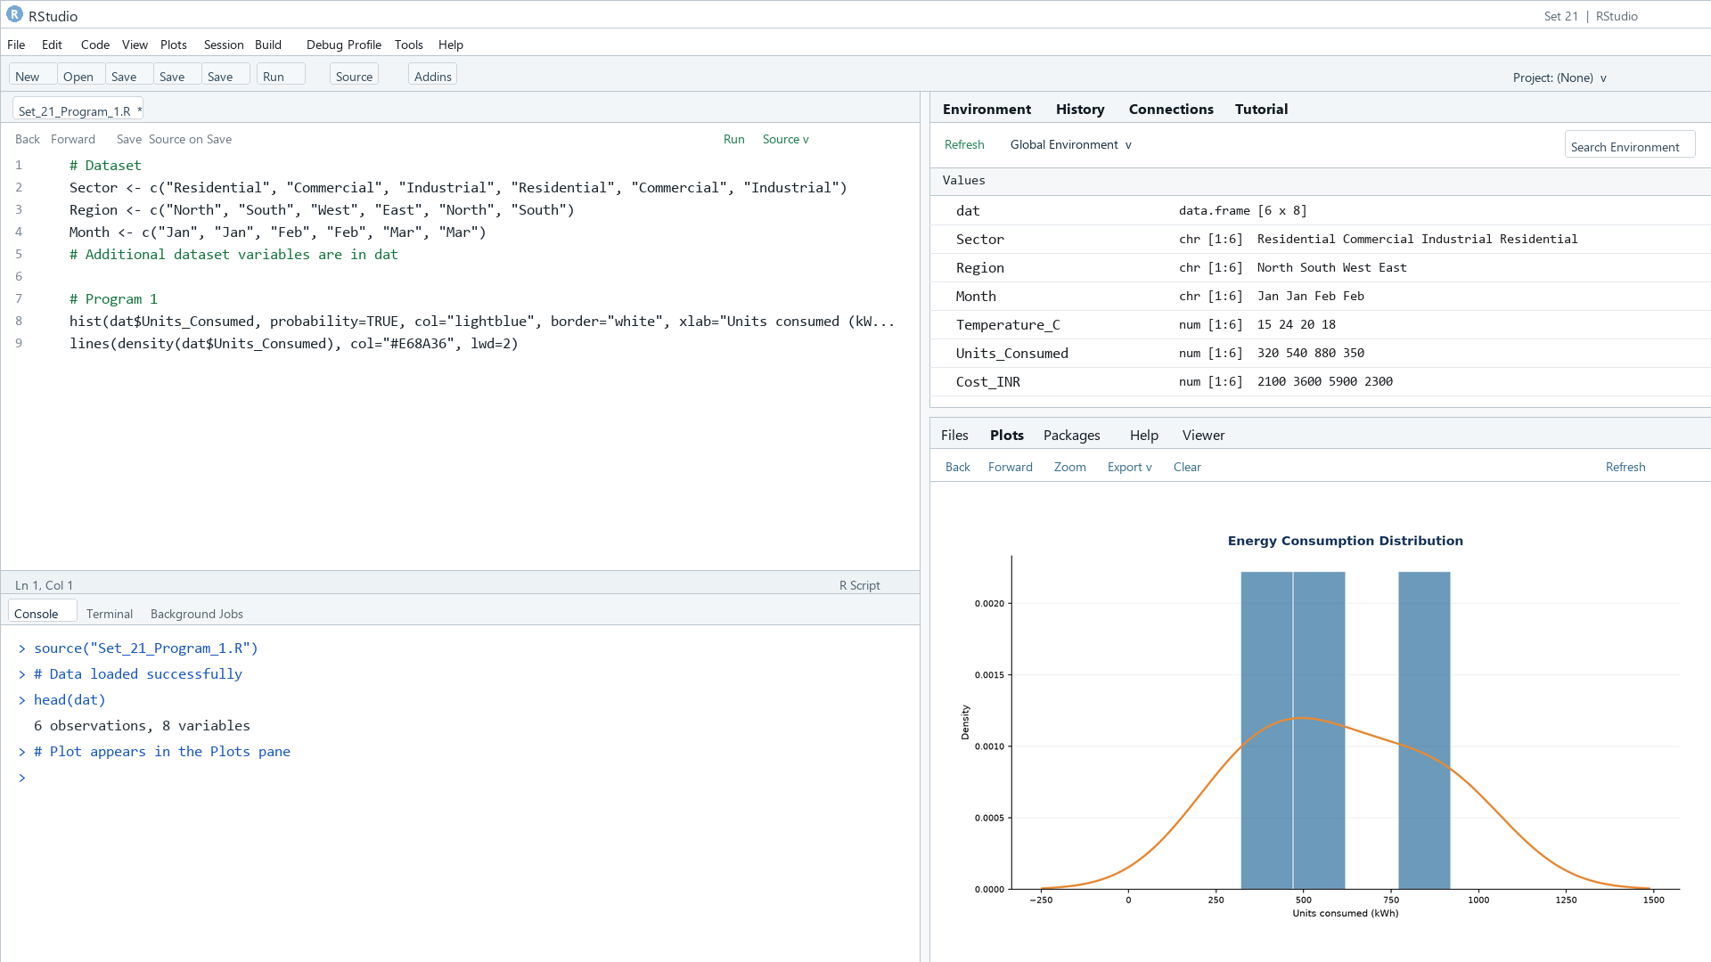

Output 1: Histogram and Density of Energy Use

Observation: The six records span 320 to 920 kWh, with higher observations from Industrial rows. The sample is too small for a stable distribution estimate.

PROGRAM 2: Temperature vs Energy Use Bubble Plot
Create a bubble scatter plot of Temperature versus Units_Consumed, with Peak_Hours shown by bubble size and transparency.
R code
plot(dat$Temperature_C, dat$Units_Consumed, pch=21, bg=adjustcolor("#276B9A", alpha.f=.55), cex=dat$Peak_Hours/3, xlab="Temperature (°C)", ylab="Units consumed (kWh)", main="Temperature and Energy Consumption")
legend("topleft", legend="Bubble size = Peak_Hours", bty="n")

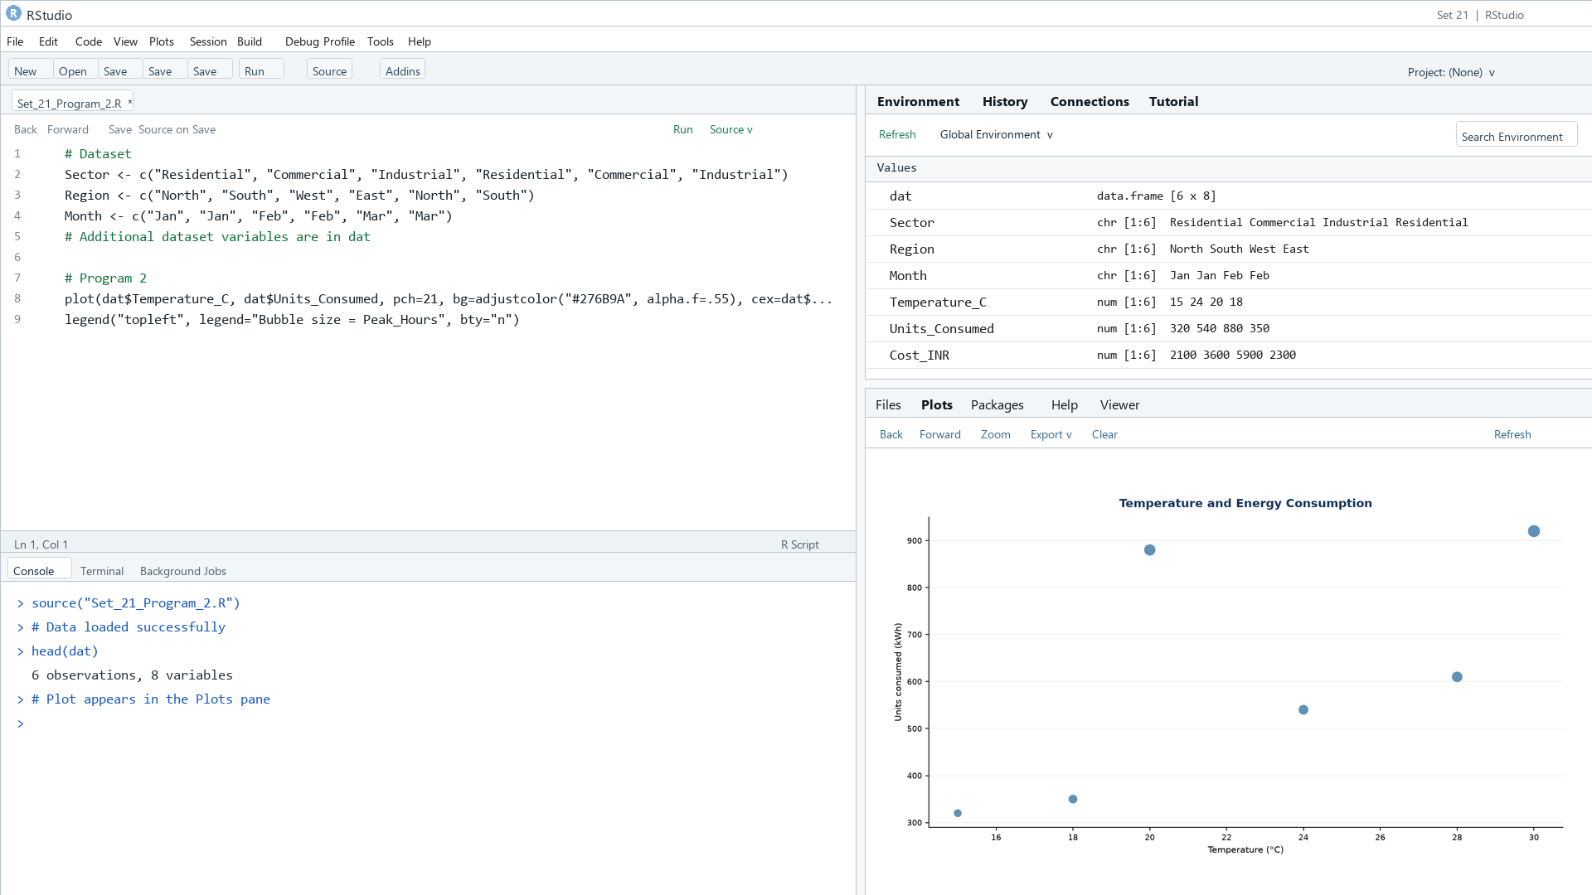

Output 2: Temperature vs Energy Use Bubble Plot

Observation: The largest consumption values occur at higher peak-hour counts; temperature and sector also vary together in this small sample.

PROGRAM 3: Renewable Usage by Sector
Calculate average Renewable_Usage for each sector, draw a labeled bar chart, and interpret adoption.
R code
avg <- aggregate(Renewable_Usage ~ Sector, dat, mean)
barplot(avg$Renewable_Usage, names.arg=avg$Sector, col=rainbow(nrow(avg)), xlab="Sector", ylab="Renewable usage (%)", main="Average Renewable Usage by Sector")

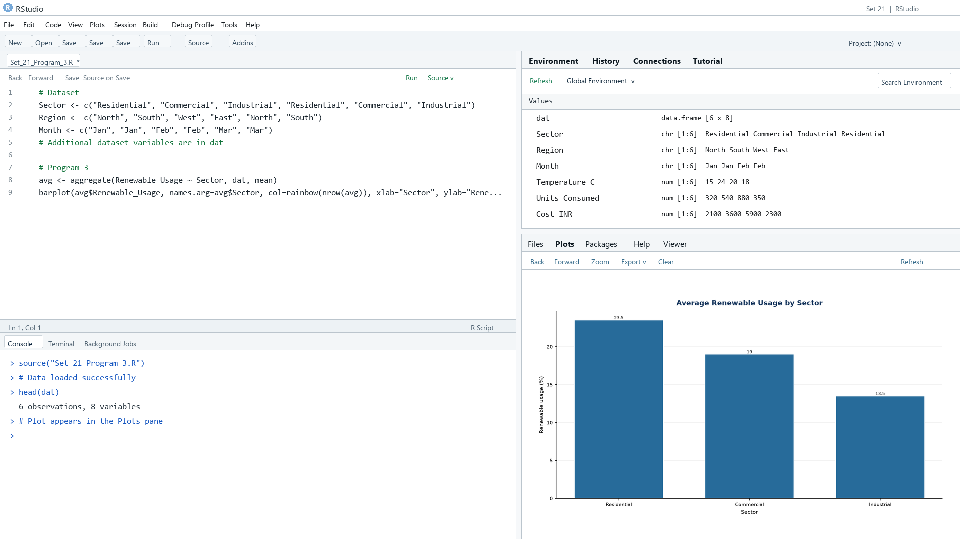

Output 3: Renewable Usage by Sector

Observation: Residential has the highest average renewable usage (23.5%); Industrial is lowest (13.5%).

PROGRAM 4: Energy Consumption Dashboard
Create a Tableau dashboard with a monthly energy-use line chart and a Sector-by-Region heatmap; add Month and Sector filters.
Tableau build steps
Tableau dashboard build
1. Connect to Energy_Consumption_Data.csv or enter the displayed records.
2. Build a line chart of SUM(Units_Consumed) by Month.
3. Build a heatmap with Sector and Region, colored by SUM(Units_Consumed).
4. Add Month and Sector filters and place both sheets on a dashboard.

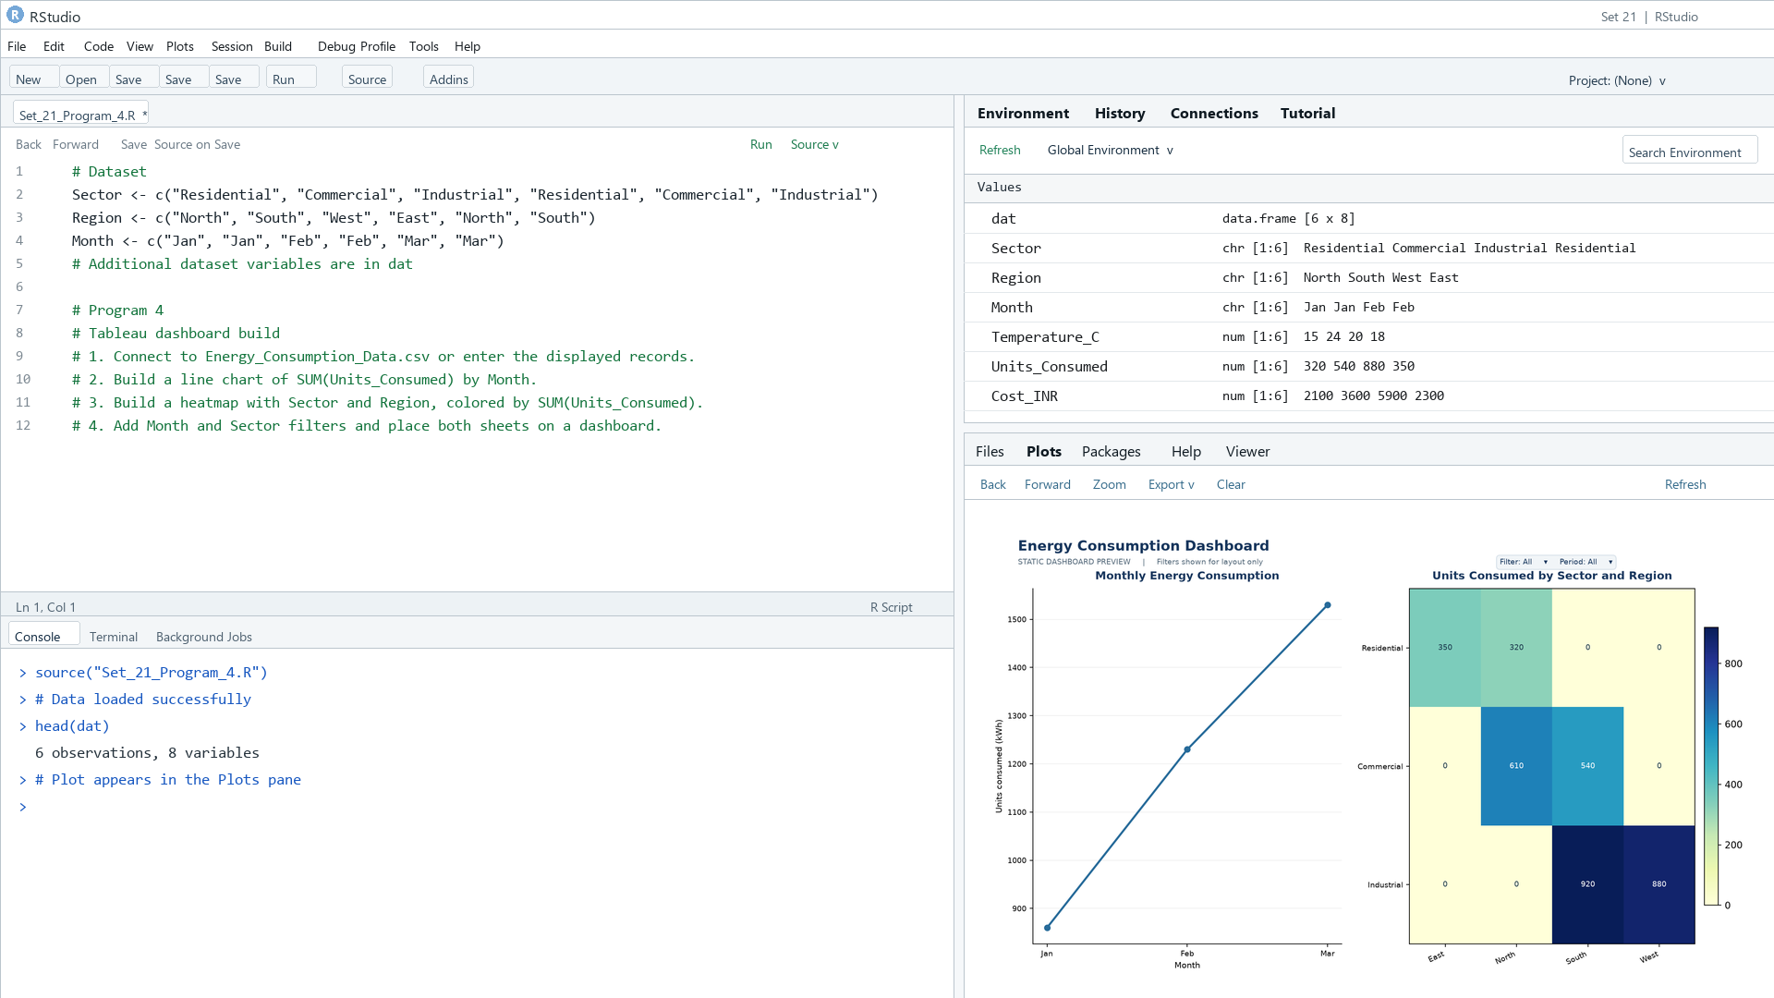

Output 4: Energy Consumption Dashboard

Observation: The preview shows monthly consumption increasing from January to March and highlights the highest sector-region cells. Month and Sector filters are specified for Tableau.

Procedure
1. Review the dataset table and confirm any illustrative fields noted in the record.
2. Run the R setup block once, then run the requested program code.
3. Compare the output screenshot with the observation and replace illustrative values when actual data is available.
4. For Tableau tasks, connect to the displayed data and follow the dashboard build steps.

Result
The requested charts and dashboard views for Set 21 were prepared from the displayed dataset. Outputs include labels, short observations, and code or dashboard construction steps.

Key Functions Used
plot(), barplot(), hist(), boxplot(), table().

